ASSIGNMNENT -7

Q-1) Write a query that counts all orders for Octomber 3.

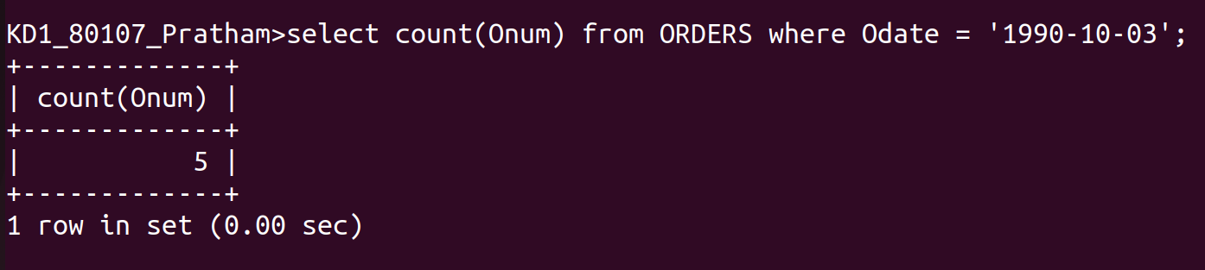

Q-2) Write a query that counts the number of different non-NULL city values in the Customers table.

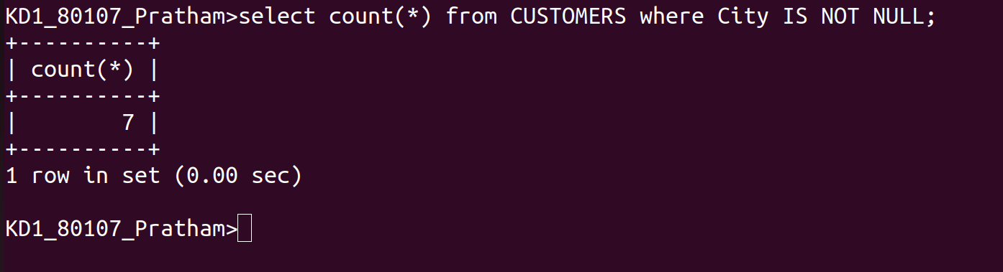

Q-3)Write a query that selects each customer’s smallest order.



Q-4) Write a query that selects the first customer,in alphabetical order, whose name begins with G.

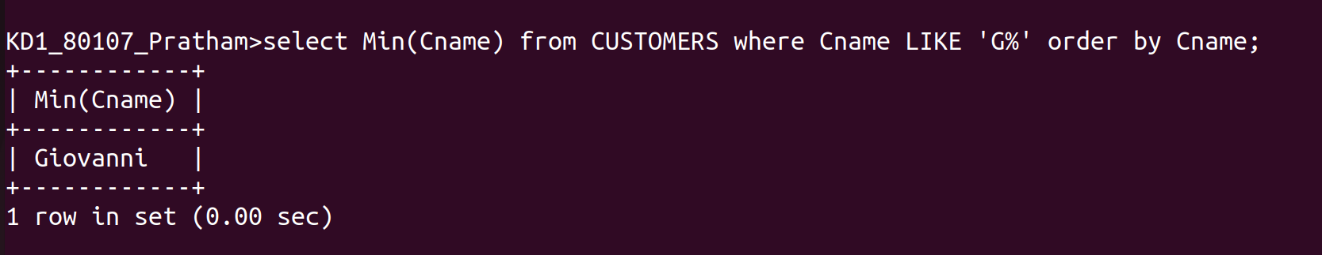

Q-5) Write a query that selects the highest rating in each day.



Q-6) Write a query that counts the number of salespeople registering orders for each day.(if a salesperson has more than one order on a given day he or she should be counted only once).
